assignemnt 1 ML

2022-09-22

#1. Download a dataset from the web. You may use any source, but specify the source in  
# your code. Also ensure that the data has a mix of quantitative and qualitative  
# (categorical) variables.  
# 2. Import the dataset into R  
# I have taken the Cars Dataset Present in R .  
data("mtcars")  
  
  
# 3. Print out descriptive statistics for a selection of quantitative and categorical variables.  
head(mtcars)

## mpg cyl disp hp drat wt qsec vs am gear carb  
## Mazda RX4 21.0 6 160 110 3.90 2.620 16.46 0 1 4 4  
## Mazda RX4 Wag 21.0 6 160 110 3.90 2.875 17.02 0 1 4 4  
## Datsun 710 22.8 4 108 93 3.85 2.320 18.61 1 1 4 1  
## Hornet 4 Drive 21.4 6 258 110 3.08 3.215 19.44 1 0 3 1  
## Hornet Sportabout 18.7 8 360 175 3.15 3.440 17.02 0 0 3 2  
## Valiant 18.1 6 225 105 2.76 3.460 20.22 1 0 3 1

min(mtcars$hp)

## [1] 52

max(mtcars$qsec)

## [1] 22.9

summary(mtcars)

## mpg cyl disp hp   
## Min. :10.40 Min. :4.000 Min. : 71.1 Min. : 52.0   
## 1st Qu.:15.43 1st Qu.:4.000 1st Qu.:120.8 1st Qu.: 96.5   
## Median :19.20 Median :6.000 Median :196.3 Median :123.0   
## Mean :20.09 Mean :6.188 Mean :230.7 Mean :146.7   
## 3rd Qu.:22.80 3rd Qu.:8.000 3rd Qu.:326.0 3rd Qu.:180.0   
## Max. :33.90 Max. :8.000 Max. :472.0 Max. :335.0   
## drat wt qsec vs   
## Min. :2.760 Min. :1.513 Min. :14.50 Min. :0.0000   
## 1st Qu.:3.080 1st Qu.:2.581 1st Qu.:16.89 1st Qu.:0.0000   
## Median :3.695 Median :3.325 Median :17.71 Median :0.0000   
## Mean :3.597 Mean :3.217 Mean :17.85 Mean :0.4375   
## 3rd Qu.:3.920 3rd Qu.:3.610 3rd Qu.:18.90 3rd Qu.:1.0000   
## Max. :4.930 Max. :5.424 Max. :22.90 Max. :1.0000   
## am gear carb   
## Min. :0.0000 Min. :3.000 Min. :1.000   
## 1st Qu.:0.0000 1st Qu.:3.000 1st Qu.:2.000   
## Median :0.0000 Median :4.000 Median :2.000   
## Mean :0.4062 Mean :3.688 Mean :2.812   
## 3rd Qu.:1.0000 3rd Qu.:4.000 3rd Qu.:4.000   
## Max. :1.0000 Max. :5.000 Max. :8.000

# 4. Transform at least one variable. It doesn't matter what the transformation is.  
squareroot<-sqrt(mtcars$hp)  
print(squareroot)

## [1] 10.488088 10.488088 9.643651 10.488088 13.228757 10.246951 15.652476  
## [8] 7.874008 9.746794 11.090537 11.090537 13.416408 13.416408 13.416408  
## [15] 14.317821 14.662878 15.165751 8.124038 7.211103 8.062258 9.848858  
## [22] 12.247449 12.247449 15.652476 13.228757 8.124038 9.539392 10.630146  
## [29] 16.248077 13.228757 18.303005 10.440307

# 5. Plot at least one quantitative variable, and one scatterplot  
hist(mtcars$drat)

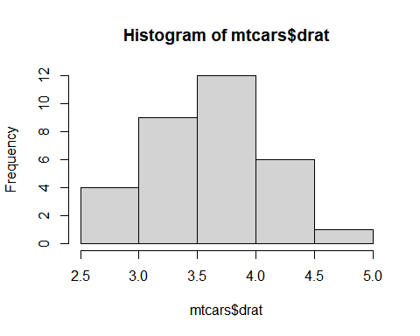

plot(mtcars$hp, mtcars$qsec,main="scatter Plot for HorsePower vs Qsec")

